**1. Run Ansible Ad-hoc commands:**

**1.1 To execute command in bash and see the result**



**1.2 To check all running processes on node.**

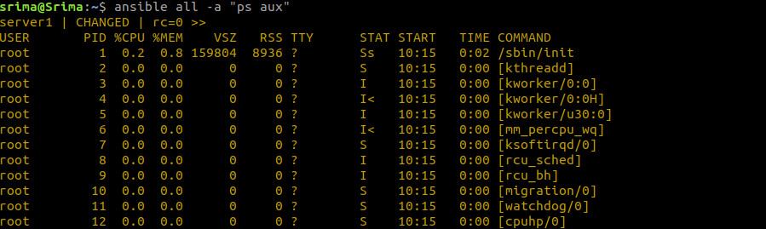

**1.3 To copying files to multiple nodes concurrently.**

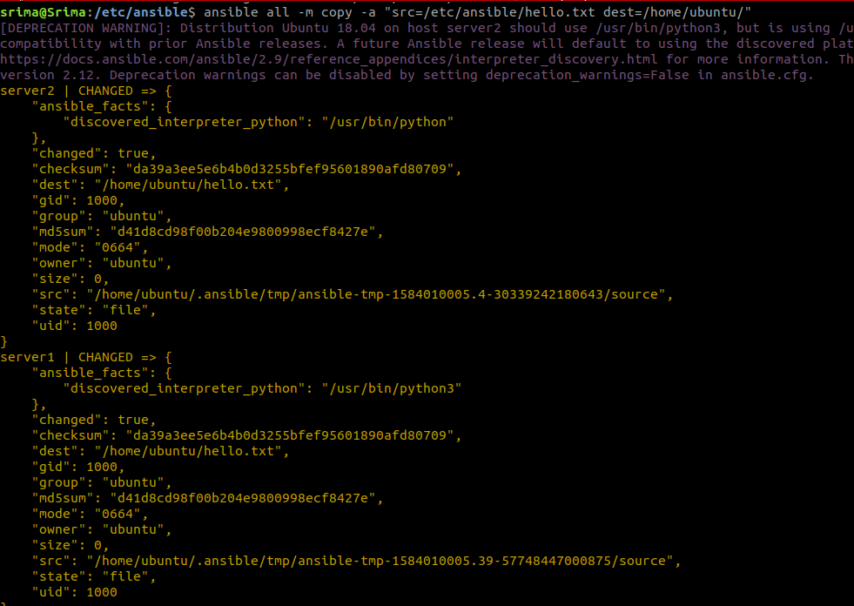

**1.4 To add and delete users.**

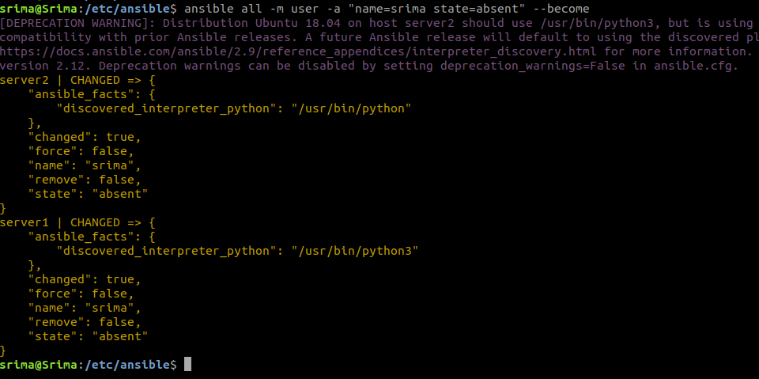

**2. Create nginx ansible-playbook and run the node, also check if nginx service and default page is running or not.**

Create ansible playbook

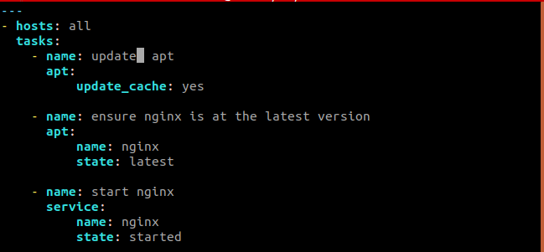

Run ansible playbook

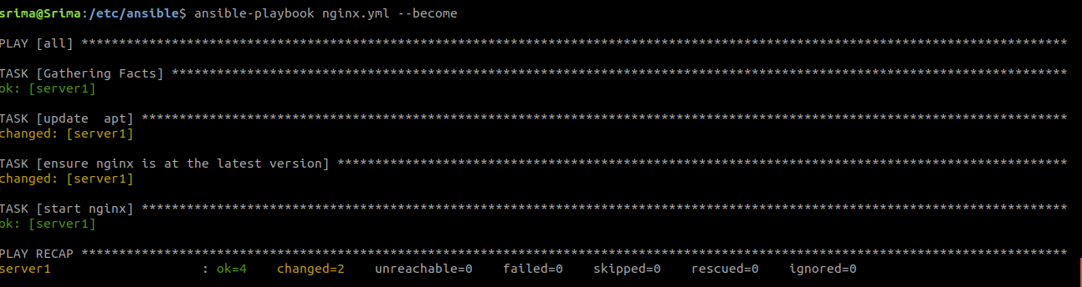

Check if default page is displaying

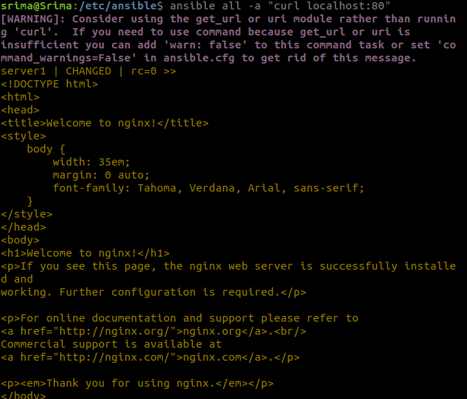

Check if service is running

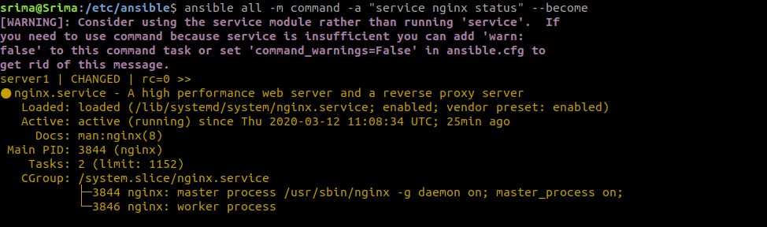

**3. Create the roles for the same playbook and use custom conf file and index.html.**

Create role directory structure

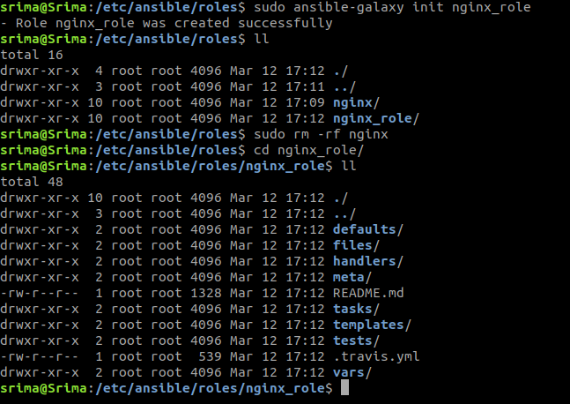

In the tasks main.yml

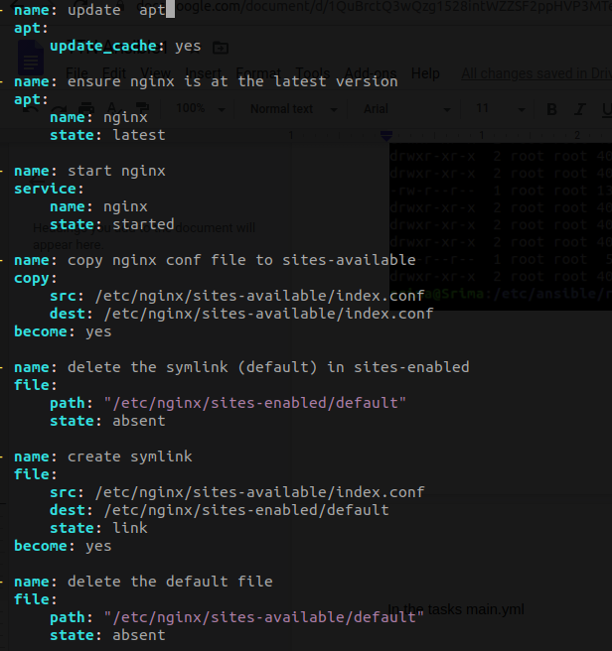

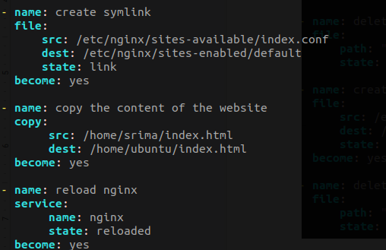

Ansible playbook

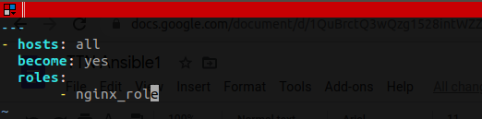

Run the ansible playbook

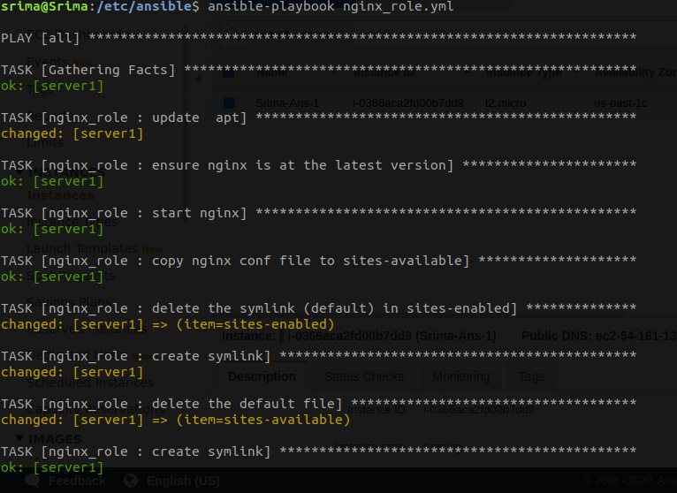

Go to the server and check if the custom site is running

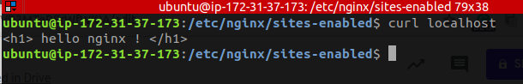

**4. Using loops, copy multiple files from ansible machine to remote node.**

Ansible playbook

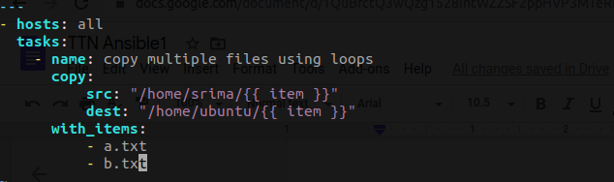

Run ansible playbook

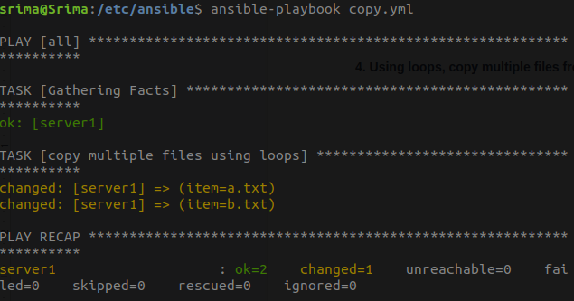

On the remote machine

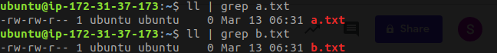

**5. Write a playbook to demonstrate the precedence of default and var file, override them from CLI.**

Create a role



Go to defaults folder and define the variable var

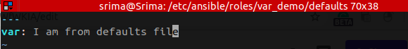

Go to vars folder and define the variable var

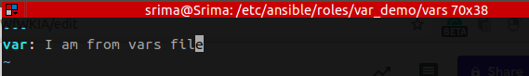

Tasks folder

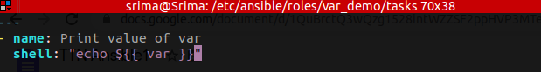

Playbook

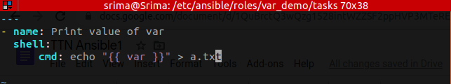

Output when we pass external argument

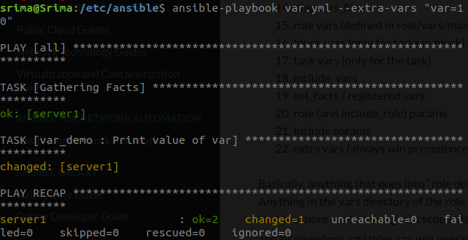

Output when we have mentioned var value in vars folder

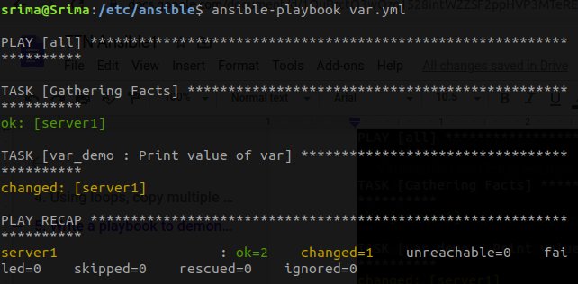



Output when we have mentioned vars value only in defaults folder



